**Rishab Verma**

**Assignment 1 Report – ECE 566**

**18th Feb 2020**

**This report contains answers to Question 3 and 4.**

**For problem 4, graphs 1 to 8 are shown which give the total number of solutions obtained from the input and compare the number of backtracks obtained from the two different algorithms. Graph 9 is a comparison for the total number of backtracks for each input. Results of all inputs can be found in the attached txt files.**

3.1) Formulate this problem as a CSP –

Z = {Q1,Q2,Q3,Q4,Q5,Q6,Q7,Q8}

Qi = Position of queen i.

Di = {A,BC,D,E,F,G,H} or {1,2,3,4,5,6,7,8} Depending on the labels of the columns

C = Not Attack(Qi, Qj) where I and j are between 1 … 8 and equal to each other.

Not attack function is straight forward due to the movement of the Queens.

This problem is a Binary CSP as the constrains are bound by C = NotAttack(Qi, Qj)

Constraint graph =

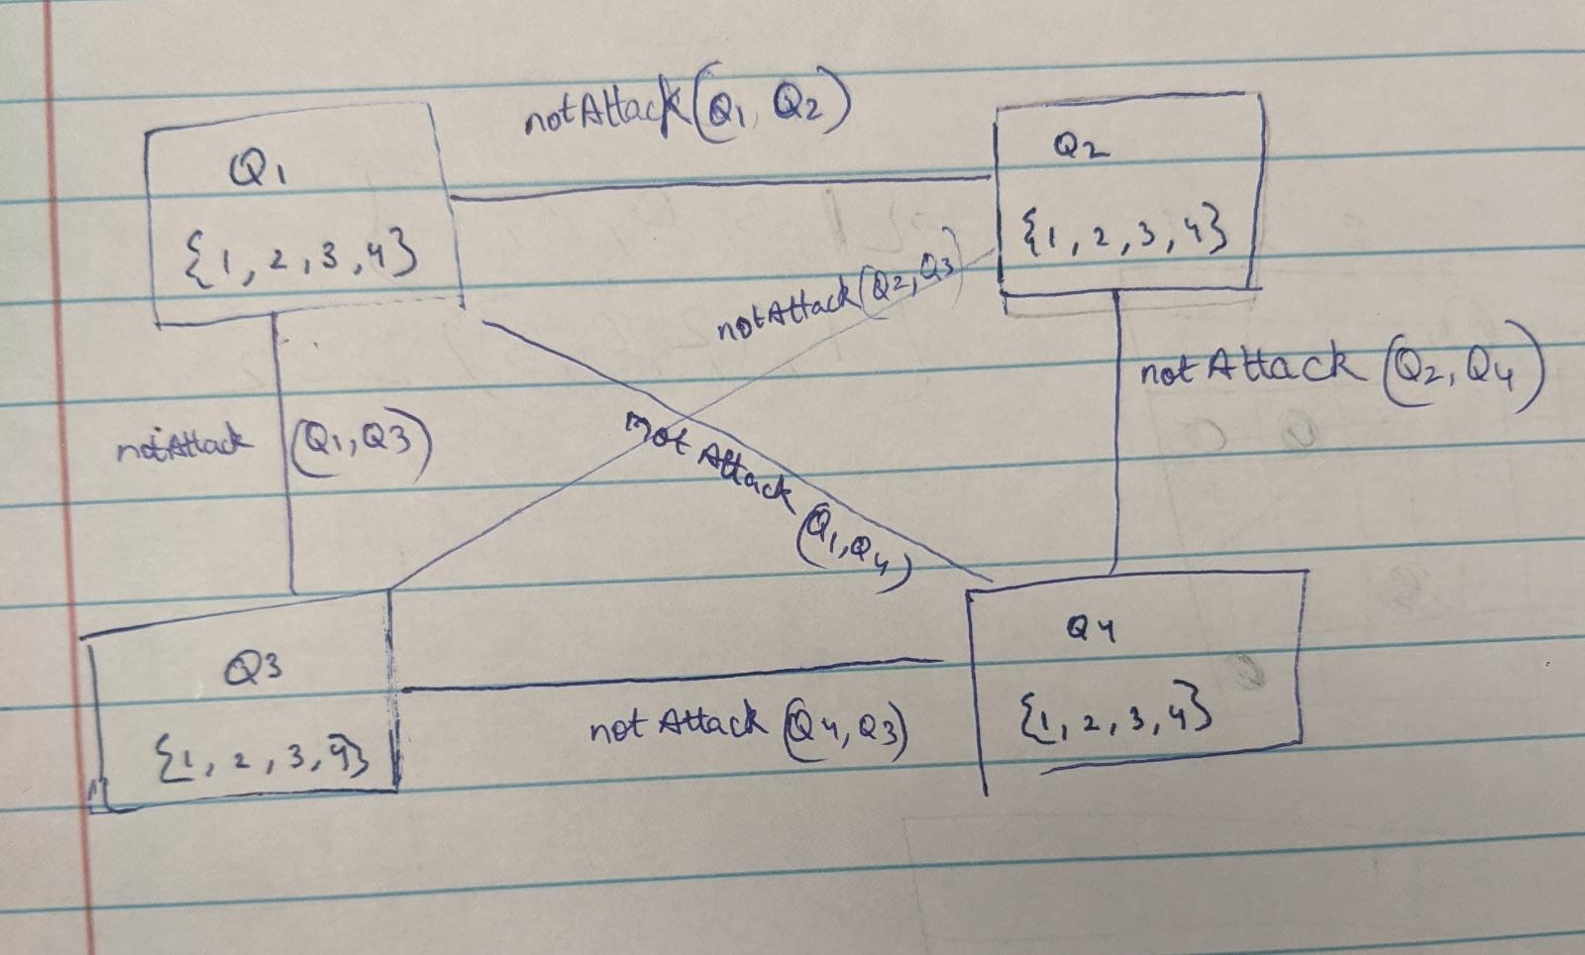

4.a) Solution for all possible inputs are attached as Text Files submitted with this document.

A1.txt, B1.txt, C1.txt, D1.txt,E1.txt, F1.txt,G1.txt,H1.txt

4.b) a)

1) Number of backtracks when A1 is input: -

2) Number of backtracks when B1 is input: -

3) Number of backtracks when C1 is input: -

4) Number of backtracks when D1 is input: -

5) Number of backtracks when E1 is input: -

6) Number of backtracks when F1 is input: -

7) Number of backtracks when G1 is input: -

8) Number of backtracks when H1 is input: -

9) Total Comparison of back tracks